Q1) Calculate the Turn-around time and waiting time of the processes on the basis of round robin scheduling algorithm. Assume Time Quantum is set to 2 units. Also calculate the average waiting time and turn-around time.

|  |  |  |
| --- | --- | --- |
| P  No. | AT | BT |
| 1 | 0 | 4 |
| 2 | 1 | 5 |
| 3 | 2 | 2 |
| 4 | 3 | 1 |
| 5 | 4 | 6 |
| 6 | 6 | 3 |

Solution-

Ready State : P1 P2 P3 P1 P4 P5 P2 P6 P5 P2 P6 P5

[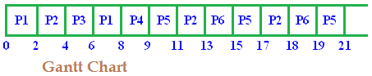](https://i1.wp.com/www.edugrabs.com/wp-content/uploads/2015/07/RR1.png)

|  |  |  |  |  |  |
| --- | --- | --- | --- | --- | --- |
| P  No. | AT | BT | CT | TAT | WT |
| 1 | 0 | 4 | 8 | 8 | 4 |
| 2 | 1 | 5 | 18 | 17 | 12 |
| 3 | 2 | 2 | 6 | 4 | 2 |
| 4 | 3 | 1 | 9 | 6 | 5 |
| 5 | 4 | 6 | 21 | 17 | 11 |
| 6 | 6 | 3 | 19 | 13 | 10 |
|  |  |  |  | 67/6=10.8 | 46/6=7.3 |

Q2) Calculate the Turn-around time and waiting time of the processes on the basis of round robin scheduling algorithm. Assume Time Quantum is set to 3 units. Also calculate the average waiting time and turn-around time.

|  |  |  |
| --- | --- | --- |
| P No. | AT | BT |
| 1 | 5 | 5 |
| 2 | 4 | 6 |
| 3 | 3 | 7 |
| 4 | 1 | 9 |
| 5 | 2 | 2 |
| 6 | 6 | 3 |

**Solution-**

Ready State : P4 P5 P3 P2 P4 P1 P6 P3 P2 P4 P1 P3

[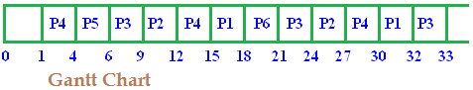](https://i2.wp.com/www.edugrabs.com/wp-content/uploads/2015/07/gantt-1.png)

|  |
| --- |
|  |
| P No. | | AT | BT | CT | TAT | WT |
| 1 | | 5 | 5 | 31 | 26 | 21 |
| 2 | | 4 | 6 | 29 | 25 | 19 |
| 3 | | 3 | 7 | 32 | 29 | 22 |
| 4 | | 1 | 9 | 26 | 25 | 16 |
| 5 | | 2 | 2 | 5 | 3 | 1 |
| 6 | | 6 | 3 | 20 | 14 | 11 |
|  | |  |  |  | 128/6=21.3 | 92/6=15.3 |

**First-Come, First Serve**

* non-preemptive scheduling management
* ready queue is managed as a FIFO queue
* example: 3 jobs arrive at time 0 in the following order (batch processing):

|  |  |  |  |  |  |  |
| --- | --- | --- | --- | --- | --- | --- |
| Process | Burst Time | Arrival | Start | Wait | Finish | TA |
| 1 | 24 | 0 | 0 | 0 | 24 | 24 |
| 2 | 3 | 0 | 24 | 24 | 27 | 27 |
| 3 | 3 | 0 | 27 | 27 | 30 | 30 |

* Gantt chart:   
    
  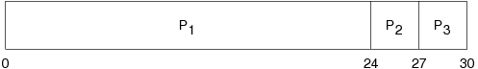  
    
  (regenerated from [OSC8] p. 189)  
  (regenerated from [OSCJ8] p. 199)
* average waiting time: (0+24+27)/3 = 17
* average turnaround time: (24+27+30) = 27
* consider arrival order: 2, 3, 1

|  |  |  |  |  |  |  |
| --- | --- | --- | --- | --- | --- | --- |
| Process | Burst Time | Arrival | Start | Wait | Finish | TA |
| 2 | 3 | 0 | 0 | 0 | 3 | 3 |
| 3 | 3 | 0 | 3 | 3 | 6 | 6 |
| 1 | 24 | 0 | 6 | 6 | 30 | 30 |

* Gantt chart:   
    
  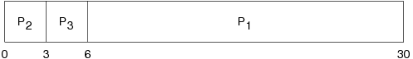  
    
  (regenerated from [OSC9] p. 189)  
  (regenerated from [OSCJ8] p. 199)
* average waiting time: (0+3+6)/3 = 3
* average turnaround time: (3+6+30) = 13
* another example:

|  |  |  |  |  |  |  |
| --- | --- | --- | --- | --- | --- | --- |
| Process | Burst Time | Arrival | Start | Wait | Finish | TA |
| 1 | 12 | 0 | 0 | 0 | 12 | 12 |
| 2 | 6 | 1 | 12 | 11 | 18 | 17 |
| 3 | 9 | 4 | 18 | 14 | 27 | 23 |

* Gantt chart:   
    
  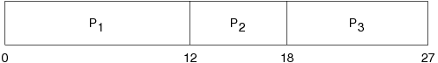
* average waiting time: (0+11+14)/3 = 8.33
* average turnaround time: (12+17+23) = 52/3 = 17.33
* another example:

|  |  |  |  |  |  |  |
| --- | --- | --- | --- | --- | --- | --- |
| Process | Burst Time | Arrival | Start | Wait | Finish | TA |
| 1 | 10 | 0 | 0 | 0 | 10 | 10 |
| 2 | 29 | 0 | 10 | 10 | 39 | 39 |
| 3 | 3 | 0 | 39 | 39 | 42 | 42 |
| 4 | 7 | 0 | 42 | 42 | 49 | 49 |
| 5 | 12 | 0 | 49 | 49 | 61 | 61 |

* Gantt chart:   
    
  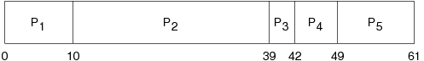  
    
  (regenerated from [OSC8] p. 214)  
  (regenerated from [OSCJ8] p. 229)
* average waiting time: (0+10+39+42+49)/5 = 28
* average turnaround time: (10+39+42+49+61)/5 = 40.2

**Priority Scheduling**

* associate a priority with each process, allocate the CPU to the process with the highest priority
* any 2 processes with the same priority are handled FCFS
* SJF is a version of priority scheduling where the priority is defined using the predicted CPU burst length
* priorities are usually numeric over a range
* high numbers may indicate low priority (system dependent)
* internal (process-based) priorities: time limits, memory requirements, resources needed, burst ratio
* external (often political) priorities: importance, source (e.g., faculty, student)
* priority scheduling can be non-preemptive or preemptive
* problem: *starvation* --- low priority processes may never execute because they are waiting indefinitely for the CPU
* a solution: *aging* --- increase the priority of a process as time progresses
* nice in UNIX executes a utility with an altered scheduling priority
* renice in UNIX alters the priority of running processes

**Shortest Job First (SJF)**

* associate with each process the length of its next CPU burst
* schedule the process with the shortest time
* two schemes
  + non-preemptive: once scheduled, a process continues until the end of its CPU burst
  + preemptive: preempt if a new process arrives with a CPU burst of less length than the *remaining time* of the currently executing process; known as the *Shortest Remaining Time First* (SRTF) algorithm
* SJF is provably optimal; it yields a minimum average waiting time for any set of processes
* however, we cannot always predict the future (i.e., we do not know the next burst length)
* we can only estimate its length
* an estimate can be formed by using the length of its previous CPU bursts:

*Tn* = actual length of the nth CPU burst

ψn = predicted value of nth CPU burst

0 <= *w* <= 1

ψ*n*+1 = *w* * *Tn* + (1-*w*) * ψn

**SJF (non-preemptive) examples**

* example 1:

|  |  |  |  |  |  |  |
| --- | --- | --- | --- | --- | --- | --- |
| Process | Burst Time | Arrival | Start | Wait | Finish | TA |
| 1 | 6 | 0 | 3 | 3 | 9 | 9 |
| 2 | 8 | 0 | 16 | 16 | 24 | 24 |
| 3 | 7 | 0 | 9 | 9 | 16 | 16 |
| 4 | 3 | 0 | 0 | 0 | 3 | 3 |

* Gantt chart:   
    
  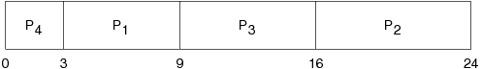  
    
  (regenerated from [OSC8] p. 190)  
  (regenerated from [OSCJ8] p. 200)
* average waiting time: (3+16+9+0)/4 = 7
* average turnaround time: (9+24+16+3)/4 = 13
* example 2:

|  |  |  |  |  |  |  |
| --- | --- | --- | --- | --- | --- | --- |
| Process | Burst Time | Arrival | Start | Wait | Finish | TA |
| 1 | 7 | 0 | 0 | 0 | 7 | 7 |
| 2 | 4 | 2 | 8 | 6 | 12 | 10 |
| 3 | 1 | 4 | 7 | 3 | 8 | 4 |
| 4 | 4 | 5 | 12 | 7 | 16 | 11 |

* Gantt chart:   
    
  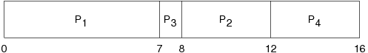
* average waiting time: (0+6+3+7)/4 = 4
* average turnaround time: (7+4+10+11)/4 = 8
* example 3:

|  |  |  |  |  |  |  |
| --- | --- | --- | --- | --- | --- | --- |
| Process | Burst Time | Arrival | Start | Wait | Finish | TA |
| 1 | 10 | 0 | 10 | 10 | 20 | 20 |
| 2 | 29 | 0 | 32 | 32 | 61 | 61 |
| 3 | 3 | 0 | 0 | 0 | 3 | 3 |
| 4 | 7 | 0 | 3 | 3 | 10 | 10 |
| 5 | 12 | 0 | 20 | 20 | 32 | 32 |

* Gantt chart:   
    
  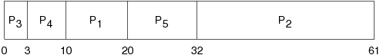  
    
  (regenerated from [OSC8] p. 214)  
  (regenerated from [OSCJ8] p. 229)
* average waiting time: (10+32+0+3+20)/5 = 13
* average turnaround time: (10+39+42+49+61)/5 = 25.2

**SRTF (preemptive) examples**

* example 1:

|  |  |  |  |  |  |  |
| --- | --- | --- | --- | --- | --- | --- |
| Process | Burst Time | Arrival | Start | Wait | Finish | TA |
| 1 | 8 | 0 | 0 | 9 | 17 | 17 |
| 2 | 4 | 1 | 1 | 0 | 5 | 4 |
| 3 | 9 | 2 | 17 | 15 | 26 | 24 |
| 4 | 5 | 3 | 5 | 2 | 10 | 7 |

* Gantt chart:   
    
  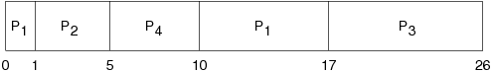  
    
  (regenerated from [OSC8] p. 192)  
  (regenerated from [OSCJ8] p. 202)
* average waiting time: (9+0+15+2)/4 = 6.5
* average turnaround time: (17+4+24+7)/4 = 13
* example 2:

|  |  |  |  |  |  |  |
| --- | --- | --- | --- | --- | --- | --- |
| Process | Burst Time | Arrival | Start | Wait | Finish | TA |
| 1 | 7 | 0 | 0 | 9 | 16 | 16 |
| 2 | 4 | 2 | 2 | 1 | 7 | 5 |
| 3 | 1 | 4 | 4 | 0 | 5 | 1 |
| 4 | 4 | 5 | 7 | 2 | 11 | 6 |

* Gantt chart:   
    
  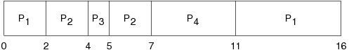
* average waiting time: (9+1+0+2)/4 = 3
* average turnaround time: (16+5+1+6)/4 = 7

**Priority Scheduling example**

|  |  |  |  |  |  |  |  |
| --- | --- | --- | --- | --- | --- | --- | --- |
| Process | Burst Time | Priority | Arrival | Start | Wait | Finish | TA |
| 1 | 10 | 3 | 0 | 6 | 6 | 16 | 16 |
| 2 | 1 | 1 | 0 | 0 | 0 | 1 | 1 |
| 3 | 2 | 4 | 0 | 16 | 16 | 18 | 18 |
| 4 | 1 | 5 | 0 | 18 | 18 | 19 | 19 |
| 5 | 5 | 2 | 0 | 1 | 1 | 6 | 6 |

Gantt chart:   
  
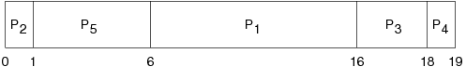  
  
(regenerated from [OSC8] p. 193)  
(regenerated from [OSCJ8] p. 203)

average waiting time: (6+0+16+18+1)/5 = 8.2

average turnaround time: (1+6+16+18+19)/5 = 12

**Round Robin**

* time sharing (preemptive) scheduler where each process is given access to the CPU for 1 time quantum (slice) (e.g., 20 milliseconds)
* a process may block itself before its time slice expires
* if it uses its entire time slice, it is then preempted and put at the end of the ready queue
* the ready queue is managed as a FIFO queue and treated as a circular
* if there are *n* processes on the ready queue and the time quantum is *q*, then each process gets 1/*n* time on the CPU in chunks of at most *q* time units
* no process waits for more than (*n*-1)*q* time units
* the choice of how big to make the time slice (*q*) is extremely important
  + if *q* is very large, Round Robin degenerates into FCFS
  + if *q* is very small, the context switch overhead defeats the benefits
* example 1 (*q* = 20):

|  |  |  |  |  |  |  |
| --- | --- | --- | --- | --- | --- | --- |
| Process | Burst Time | Arrival | Start | Wait | Finish | TA |
| 1 | 53 | 0 | 0 | ? | 134 | 134 |
| 2 | 17 | 0 | 20 | ? | 37 | 37 |
| 3 | 68 | 0 | 37 | ? | 162 | 162 |
| 4 | 24 | 0 | 57 | ? | 121 | 121 |

* Gantt chart:   
    
  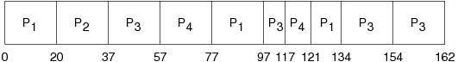
* waiting times:
* p1: (77-20) + (121-97) = 81
* p2: (20-0) = 20
* p3: (37-0) + (97-57) + (134-117) = 94
* p4: (57-0) + (117-77) = 97
* average waiting time: (81+20+94+97)/4 = 73
* example 2 (*q* = 4):

|  |  |  |  |  |  |  |
| --- | --- | --- | --- | --- | --- | --- |
| Process | Burst Time | Arrival | Start | Wait | Finish | TA |
| 1 | 24 | 0 | 0 | 6 | 30 | 30 |
| 2 | 3 | 0 | 4 | 4 | 7 | 7 |
| 3 | 3 | 0 | 7 | 7 | 10 | 10 |

* Gantt chart:   
    
  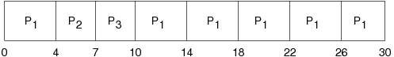  
    
  (regenerated from [OSC8] p. 194) (regenerated from [OSCJ8] p. 204)
* average waiting time: (6+4+7)/3 = 5.67
* average turnaround time: (30+7+10)/3 = 15.67
* example 3 (*q* = 10):

|  |  |  |  |  |  |  |
| --- | --- | --- | --- | --- | --- | --- |
| Process | Burst Time | Arrival | Start | Wait | Finish | TA |
| 1 | 10 | 0 | 0 | 0 | 10 | 10 |
| 2 | 29 | 0 | 10 | 32 | 61 | 61 |
| 3 | 3 | 0 | 20 | 20 | 23 | 23 |
| 4 | 7 | 0 | 23 | 23 | 30 | 30 |
| 5 | 12 | 0 | 30 | 40 | 52 | 52 |

* Gantt chart:   
    
  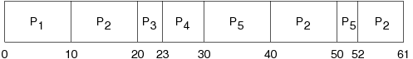
* average waiting time: (0+32+20+23+40)/5 = 23
* average turnaround time: (10+39+42+49+61)/5 = 35.2